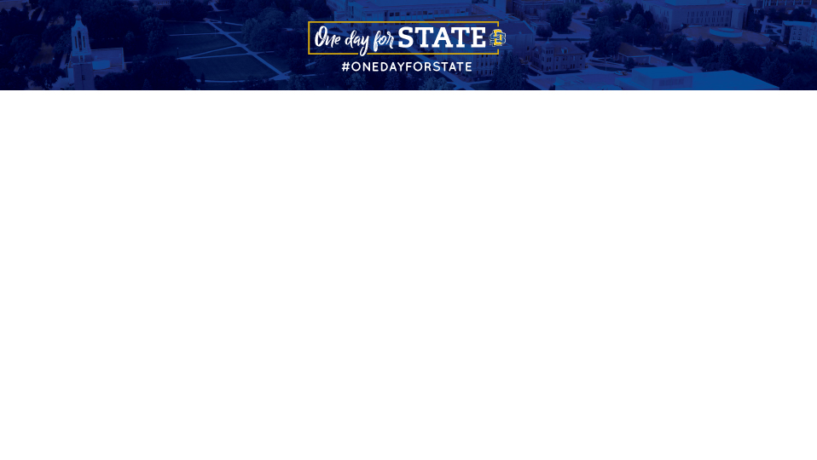
Sample Social Media Posts

To find additional inspiration, search the hashtag #OneDayforSTATE on all social media platforms.

Don’t forget to add your unique URL to every social media post. Find yours by logging in as an advocate here.

If you need help, here’s a helpful video to watch. Make your posts unique by adding videos, gifs, emojis, or photos.

Pre-Event Posts

#OneDayforSTATE is the perfect opportunity for our Jackrabbit family to come together! Will you join us on September 5? <<insert unique URL>>

- - - - - - - - - - - - - - - - - - - - - - - - - - - - - - - - - - - -

Hey, you there, scrolling <<insert social media channel>>. You should become an advocate for #OneDayforSTATE and join the social ambassador team.
- No heavy lifting
- You’re already on your phone
- Compete to win prizes
- Celebrate Jackrabbit pride
- Help raise money for SDSU

Learn more: <<insert unique URL>>

- - - - - - - - - - - - - - - - - - - - - - - - - - - - - - - - - - - -

Love SDSU as much as me? Then join the social ambassador team for #OneDayforSTATE! Check it out: <<insert unique URL>>

- - - - - - - - - - - - - - - - - - - - - - - - - - - - - - - - - - - -

#TBT to #OneDayforSTATE 2023! <<insert photo from ODFS 2022>>

Join me and the @SDSUFoundation on September 5 for #OneDayforSTATE <<insert unique URL>>

- - - - - - - - - - - - - - - - - - - - - - - - - - - - - - - - - - - -

#OneDayforSTATE is a week away. Tag a friend below to invite them to celebrate all things SDSU with us on September 5. <<insert unique URL>>

- - - - - - - - - - - - - - - - - - - - - - - - - - - - - - - - - - - -

#OneDayforSTATE is right around the corner. Tomorrow is your opportunity to make a difference. Learn more - <<insert unique URL>>

- - - - - - - - - - - - - - - - - - - - - - - - - - - - - - - - - - - -

#OneDayforSTATE is almost here, and it wouldn’t be possible without the generosity of the challenge donors. Their support helps every gift - no matter the size - make an even bigger impact. Join us tomorrow!

Learn more at: <<insert unique URL>>

- - - - - - - - - - - - - - - - - - - - - - - - - - - - - - - - - - - -

Let’s get ready to celebrate, Jackrabbits! We’re less than 24 hours away from #OneDayforSTATE! View the countdown: <<insert unique URL>>

- - - - - - - - - - - - - - - - - - - - - - - - - - - - - - - - - - - -

I’m excited to take part in SDSU’s 8th annual #OneDayforSTATE on September 5! I plan to support <<insert gift designation>>. Join me? <<insert unique URL>>

- - - - - - - - - - - - - - - - - - - - - - - - - - - - - - - - - - - -

A little can go a long way when we give together on September 5 for #OneDayforSTATE! <<insert unique URL>>

Day-Of Posts

Way past my bedtime but wanted to stay up to be the first to make a gift to <<insert gift designation>> for #OneDayforSTATE <<insert unique URL>>

- - - - - - - - - - - - - - - - - - - - - - - - - - - - - - - - - - - -

Today is #OneDayforSTATE! 24 hours to raise money for programs on the SDSU campus that you want to support. I already made my donation to the <<insert gift designation>> because <<insert reason why you gave>>. <<insert unique URL>>

- - - - - - - - - - - - - - - - - - - - - - - - - - - - - - - - - - - -

Today’s the day, Jackrabbits! 5,000 Donors. 24 Hours. Let’s do this! Tag your Jackrabbit friends below! #OneDayforSTATE <<insert unique URL>>

- - - - - - - - - - - - - - - - - - - - - - - - - - - - - - - - - - - -

When you make a gift, you make a difference. Join me and thousands of other Jackrabbits today on #OneDayforSTATE: <<insert unique URL>>

- - - - - - - - - - - - - - - - - - - - - - - - - - - - - - - - - - - -

Let’s turn the map Jackrabbit Blue! If we inspire donors from all 50 states to give a gift today, we’ll unlock challenge funds! Make a gift from your state today: <<insert unique URL>>

(Tag friends you know in the remaining states!)

- - - - - - - - - - - - - - - - - - - - - - - - - - - - - - - - - - - -

Check out my Flat Jack photo! Don’t forget to share yours today using #OneDayforSTATE and make sure your photo setting is public! Let’s show our Jackrabbit pride around the globe today! <<insert unique URL>>

- - - - - - - - - - - - - - - - - - - - - - - - - - - - - - - - - - - -

I love SDSU because <<insert reason>>! How about you? <<insert unique URL>>

- - - - - - - - - - - - - - - - - - - - - - - - - - - - - - - - - - - -

It’s #OneDayforSTATE! I owe so much of who I am to my time at SDSU. Please consider joining me in giving back at <<insert unique URL>>

- - - - - - - - - - - - - - - - - - - - - - - - - - - - - - - - - - - -

We appreciate the support of <<insert challenge donors>>! Come on, Jackrabbits! Show your support for STATE. Click here to donate now: <<insert unique URL>> #OneDayforSTATE

- - - - - - - - - - - - - - - - - - - - - - - - - - - - - - - - - - - -

A little goes a long way when Jackrabbits all over the world team up and give back. Join in and make today count: <<insert unique URL>>

- - - - - - - - - - - - - - - - - - - - - - - - - - - - - - - - - - - -

Where my Jackrabbit friends at? I challenge @name, @name, @name to join in the #OneDayforSTATE party at <<insert unique URL>>.

- - - - - - - - - - - - - - - - - - - - - - - - - - - - - - - - - - - -

On #OneDayforSTATE your gift can go even farther thanks to our challenge donors. <<insert unique URL>>

- - - - - - - - - - - - - - - - - - - - - - - - - - - - - - - - - - - -

Give today. Transform tomorrow. Join me in supporting Jackrabbits during #OneDayforSTATE. <<insert unique URL>>

- - - - - - - - - - - - - - - - - - - - - - - - - - - - - - - - - - - -

Whoop, whoop! It’s a big day for all Jackrabbits! Tag your friends below! Here’s 3 easy ways to get involved during #OneDayforSTATE:
- Make a gift - any size helps! <<insert unique URL>>
- Sign up to be a social ambassador or share my posts.
- Encourage your Jackrabbit friends to get involved too!

- - - - - - - - - - - - - - - - - - - - - - - - - - - - - - - - - - - -

Never made a gift to SDSU before? Today is the day to do it. Your gift will go further with the help of challenge donors! Every gift helps unlock additional dollars on #OneDayforSTATE. <<Insert unique url>>

- - - - - - - - - - - - - - - - - - - - - - - - - - - - - - - - - - - -

#1 Jump out of bed

#2 Toss on your favorite Jackrabbit gear

#3 Celebrate #OneDayforSTATE

#4 Click on this link to support Jackrabbits <<insert unique URL>>

- - - - - - - - - - - - - - - - - - - - - - - - - - - - - - - - - - - -

Interested in giving directly to <<insert gift designation>> for #OneDayforSTATE?

- Follow <<insert unique URL>>

- Click “Give Now”

- Enter the amount

- Select <<insert gift designation>> from the drop-down menu

- Enter your details

- Feel our appreciation

- - - - - - - - - - - - - - - - - - - - - - - - - - - - - - - - - - - -

Go Big! Go Blue! Go Jacks! We’re halfway there – 12 hours have already passed on #OneDayforSTATE. We’ve had over <<insert number of challenges>> challenges completed, and over <<insert number of donors>> donors so far. We can do this – let’s make a difference in the lives of our students! <<insert unique URL>>

- - - - - - - - - - - - - - - - - - - - - - - - - - - - - - - - - - - -

We’re coming down to the end of #OneDayforSTATE! That means if you want to support SDSU in continuing to provide opportunities for Jackrabbit students, check out the link: <<insert unique URL>>

- - - - - - - - - - - - - - - - - - - - - - - - - - - - - - - - - - - -

(Q) Are you in a better spot today because of SDSU?

If your answer is yes, then make sure to join in #OneDayforSTATE and give back to the place that’s so special to all Jackrabbits! <<insert unique URL>>

- - - - - - - - - - - - - - - - - - - - - - - - - - - - - - - - - - - -

Doing great, Jackrabbits! There are still a couple of #OneDayforSTATE challenges within reach that will unlock some very generous gifts! Every donation makes a difference! <<insert unique URL>>

- - - - - - - - - - - - - - - - - - - - - - - - - - - - - - - - - - - -

It’s not about how much you give. #OneDayforSTATE is all about honoring the University that we all love and showing your support today by making a donation. <<insert unique URL>>

- - - - - - - - - - - - - - - - - - - - - - - - - - - - - - - - - - - -

We’re over halfway to unlocking our 5,000 donor goal. Keep pushing, Jackrabbits! If you haven’t already, head to <<insert unique URL>> to make a gift. Then sign up to be a social ambassador and share, share, share! #OneDayforSTATE

- - - - - - - - - - - - - - - - - - - - - - - - - - - - - - - - - - - -

I challenge all of you to join #OneDayforSTATE by giving <<insert dollar amount - Example: $20.24>> or more in support of SDSU scholarships. Join me in supporting our current and future Jackrabbits today! <<insert unique URL>>

- - - - - - - - - - - - - - - - - - - - - - - - - - - - - - - - - - - -

Post-Event Posts

Thank you to all <<insert donor amount>> donors who rose to the challenge during #OneDayforSTATE. Together as one, we raised <<insert amount raised>>! Take a moment to think of all the new opportunities that were granted for current students at South Dakota State University yesterday! WOW!

- - - - - - - - - - - - - - - - - - - - - - - - - - - - - - - - - - - -

We did it! A big thank you to everyone for their support. We raised over <<insert amount raised>> for Jackrabbits. Thank you! #OneDayforSTATE

- - - - - - - - - - - - - - - - - - - - - - - - - - - - - - - - - - - -

What a day! A final post to say THANK YOU to everyone who helped make #OneDayforSTATE an unbelievable success. You brought the words “With Loyal Hearts So True” to life today.

- - - - - - - - - - - - - - - - - - - - - - - - - - - - - - - - - - - -

Anyone else feel like they’ve just ran a marathon? In just 24 hours, we raised more than <<insert amount raised>> from over <<insert donor amount>>. Jackrabbit nation is the best!

- - - - - - - - - - - - - - - - - - - - - - - - - - - - - - - - - - - -

Over <<insert amount raised>> dollars raised yesterday at #OneDayforSTATE!

- - - - - - - - - - - - - - - - - - - - - - - - - - - - - - - - - - - -

A big thank you to our Jackrabbit donors! We continue to set records. What a terrific way to start the school year!

#OneDayforSTATE

- - - - - - - - - - - - - - - - - - - - - - - - - - - - - - - - - - - -

Current mood:
- Still overwhelmed by the #OneDayforSTATE results
- So proud to be part of the Jackrabbit family

- - - - - - - - - - - - - - - - - - - - - - - - - - - - - - - - - - - -

That feeling when you wake up and remember more than <<insert donor amount>> donors raised over <<insert amount raised>> for SDSU Jackrabbits yesterday during #OneDayforSTATE…<<pair with a funny gif>>

- - - - - - - - - - - - - - - - - - - - - - - - - - - - - - - - - - - -

In 24 hours, more than <<insert donor amount>> donors raised over <<insert amount raised>>. Thank you, thank you, thank you Jackrabbits for making #OneDayforSTATE a success! <<insert unique URL>>

- - - - - - - - - - - - - - - - - - - - - - - - - - - - - - - - - - - -

It is nothing short of unbelievable what Jackrabbits can do when they join together to make a difference. Cheers to an amazing #OneDayforSTATE! You made a huge impact, Jackrabbits!

- - - - - - - - - - - - - - - - - - - - - - - - - - - - - - - - - - - -

Thanks to everyone who made this #OneDayforSTATE our best one yet!

- - - - - - - - - - - - - - - - - - - - - - - - - - - - - - - - - - - -

