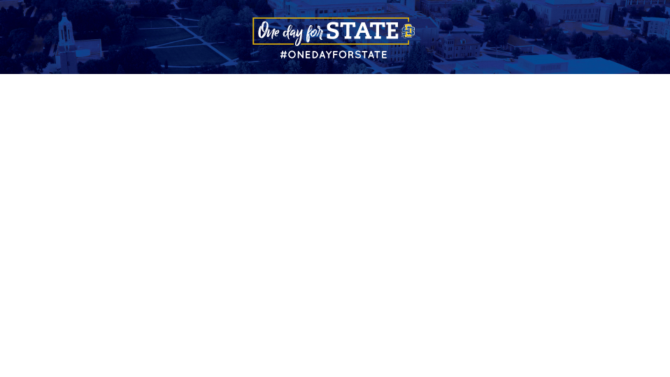
Sample Email Templates

Don’t forget to add your unique URL to every social media post. Find yours by logging in as an advocate here. If you need help, here’s a helpful video to watch.

Pre-Event

Dear <<insert name>>:
Big things can happen when Jackrabbits come together.
Last year, we rose to the challenge during the 7th Annual One Day for STATE. In 24 hours, thousands of donors from across the world joined together to raise $2.5 million for Jackrabbits during One Day for STATE.
On September 5, we’ll do it again! The objectives are simple: to rally Jackrabbits everywhere to share their passion for the yellow and blue and celebrate all it means to be a part of STATE.
I am asking you to help us reach our goal of once again rallying 5,000 donors in 24 hours by marking your calendar and making a gift at <<insert your unique URL>> on September 5. And if you want to take it a step further and join me as a digital volunteer that day, visit www.sdstatefoundation.org/socialhub to learn more!
Together as one, we can make a difference for our current and future Jackrabbits.
Sincerely,
<<insert your name>>

Day-Of Event

Dear <<insert name>>:
One Day for STATE is finally here! Today, all gifts – no matter the size – can make a difference for Jackrabbits.
Visit <<insert your unique URL>> and make a gift to a college or program that matters to you. With the help of today’s challenge donors, your gift can go even farther.
Today, I’m showing my support by donating to <<insert your gift designation>>.
SDSU played an important part of my life thanks to the generosity of others. Now, I want to pay it forward by giving back. I hope you will join me.
5,000 donors in 24 hours. It’s a bold goal, but there’s nothing the Jackrabbit family can’t do when we work together.
Visit <<insert your unique URL>> to join in the excitement.
Sincerely,

<<insert your name>>

