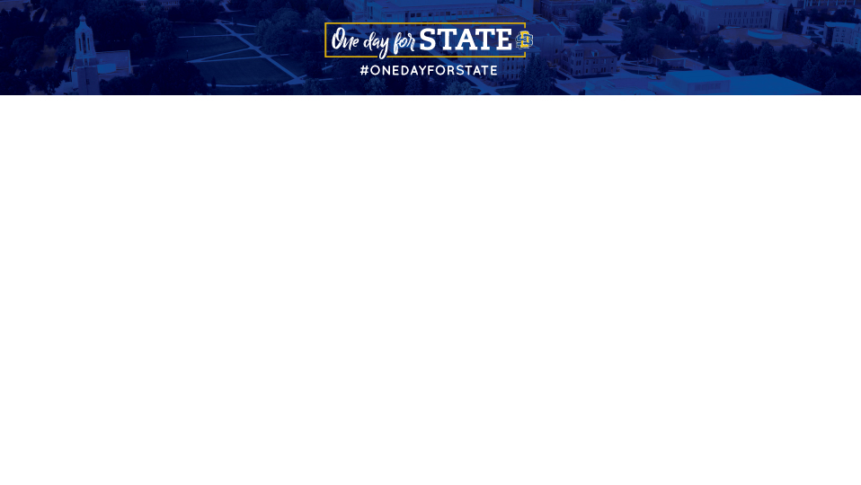
Sample Social Media Posts

Don’t forget to add your unique URL to every social media post. Find yours by logging in as an advocate here. If you need help, here’s a helpful video to watch.

Make your posts unique by adding videos, gifs, emojis, or photos.

Pre-Event Posts

#OneDayforSTATE is the perfect opportunity for our Jackrabbit family to come together! Will you join us on September 7? <<insert unique URL>>

- - - - - - - - - - - - - - - - - - - - - - - - - - - - - - - - - - - -

Hey you there, scrolling <<insert social media channel>>. You should become an advocate for #OneDayforSTATE and join the social ambassador team.
- No heavy lifting
- You’re already on your phone
- Compete to win prizes
- Celebrate Jackrabbit pride
- Help raise money for SDSU

Learn more: <<insert unique URL>>

- - - - - - - - - - - - - - - - - - - - - - - - - - - - - - - - - - - -

Love SDSU as much as me? Then join the social ambassador team for #OneDayforSTATE! Check it out: <<insert unique URL>>

- - - - - - - - - - - - - - - - - - - - - - - - - - - - - - - - - - - -

#TBT to #OneDayforSTATE 2022! <<insert photo from ODFS 2022>>

Join me and the @SDSUFoundation on September 7 for #OneDayforSTATE <<insert unique URL>>

- - - - - - - - - - - - - - - - - - - - - - - - - - - - - - - - - - - -

#OneDayforSTATE is a week away. Tag a friend below to invite them to celebrate all things SDSU with us on September 7. <<insert unique URL>>

- - - - - - - - - - - - - - - - - - - - - - - - - - - - - - - - - - - -

#OneDayforSTATE is right around the corner. Tomorrow is your opportunity to make a difference. Learn more - <<insert unique URL>>

- - - - - - - - - - - - - - - - - - - - - - - - - - - - - - - - - - - -

#OneDayforSTATE is almost here, and it wouldn’t be possible without the generosity of the challenge donors. Their support helps every gift - no matter the size - make an even bigger impact. Join us tomorrow!

Learn more at: <<insert unique URL>>

- - - - - - - - - - - - - - - - - - - - - - - - - - - - - - - - - - - -

Let’s get ready to celebrate, Jackrabbits! We’re less than 24 hours away from #OneDayforSTATE! View the countdown: <<insert unique URL>>

- - - - - - - - - - - - - - - - - - - - - - - - - - - - - - - - - - - -

I’m excited to take part in SDSU’s 7th annual #OneDayforSTATE on September 7! I plan to support <<insert gift designation>>. Join me? <<insert unique URL>>

- - - - - - - - - - - - - - - - - - - - - - - - - - - - - - - - - - - -

A little can go a long way when we give together on September 7 for #OneDayforSTATE! <<insert unique URL>>

Day-Of Posts

Way past my bedtime but wanted to stay up to be the first to make a gift to <<insert gift designation>> for #OneDayforSTATE <<insert unique URL>>

- - - - - - - - - - - - - - - - - - - - - - - - - - - - - - - - - - - -

Today is #OneDayforSTATE! 24 hours to raise money for programs on the SDSU campus that you want to support. I already made my donation to the <<insert gift designation>> because <<insert reason why you gave>>. <<insert unique URL>>

- - - - - - - - - - - - - - - - - - - - - - - - - - - - - - - - - - - -

Today’s the day, Jackrabbits! 5,000 Donors. 24 Hours. Let’s do this! Tag your Jackrabbit friends below! #OneDayforSTATE <<insert unique URL>>

- - - - - - - - - - - - - - - - - - - - - - - - - - - - - - - - - - - -

When you make a gift, you make a difference. Join me and thousands of other Jackrabbits today on #OneDayforSTATE: <<insert unique URL>>

- - - - - - - - - - - - - - - - - - - - - - - - - - - - - - - - - - - -

Let’s turn the map Jackrabbit Blue! If we inspire donors from all 50 states to give a gift today, we’ll unlock challenge funds! Make a gift from your state today: <<insert unique URL>>

(Tag friends you know in the remaining states!)

- - - - - - - - - - - - - - - - - - - - - - - - - - - - - - - - - - - -

Check out my Flat Jack photo! Don’t forget to share yours today using #OneDayforSTATE and make sure your photo setting is public! Let’s show our Jackrabbit pride around the globe today! <<insert unique URL>>

- - - - - - - - - - - - - - - - - - - - - - - - - - - - - - - - - - - -

It’s #OneDayforSTATE! I owe so much of who I am to my time at SDSU. Please consider joining me in giving back at <<insert unique URL>>

- - - - - - - - - - - - - - - - - - - - - - - - - - - - - - - - - - - -

We appreciate the support of <<insert challenge donors>>! Come on, JACKRABBITS! Show your support for STATE. Click here to donate now: <<insert unique URL>> #OneDayforSTATE

- - - - - - - - - - - - - - - - - - - - - - - - - - - - - - - - - - - -

A little goes a long way when Jackrabbits all over the world team up and give back. Join in and make today count: <<insert unique URL>>

- - - - - - - - - - - - - - - - - - - - - - - - - - - - - - - - - - - -

Where my Jackrabbit friends at? I challenge @name, @name, @name to join in the #OneDayforSTATE party at <<insert unique URL>>.

- - - - - - - - - - - - - - - - - - - - - - - - - - - - - - - - - - - -

On #OneDayforSTATE your gift can go even farther thanks to our challenge donors. <<insert unique URL>>

- - - - - - - - - - - - - - - - - - - - - - - - - - - - - - - - - - - -

Give today. Transform tomorrow. Join me in supporting Jackrabbits during #OneDayforSTATE. <<insert unique URL>>

- - - - - - - - - - - - - - - - - - - - - - - - - - - - - - - - - - - -

Whoop, whoop! It’s a big day for all Jackrabbits! Tag your friends below! Here’s 3 easy ways to get involved during #OneDayforSTATE:
- Make a gift - any size helps! <<insert unique URL>>
- Sign up to be a social ambassador or share my posts.
- Encourage your Jackrabbit friends to get involved too!

- - - - - - - - - - - - - - - - - - - - - - - - - - - - - - - - - - - -

Never made a gift to SDSU before? Today is the day to do it. Your gift will go further with the help of challenge donors! Every gift helps unlock additional dollars on #OneDayforSTATE. <<Insert unique url>>

- - - - - - - - - - - - - - - - - - - - - - - - - - - - - - - - - - - -

#1 Jump out of bed

#2 Toss on your favorite Jackrabbit gear

#3 Celebrate #OneDayforSTATE

#4 Click on this link to support Jackrabbits <<insert unique URL>>

- - - - - - - - - - - - - - - - - - - - - - - - - - - - - - - - - - - -

Interested in giving directly to <<insert gift designation>> for #OneDayforSTATE?

- Follow <<insert unique URL>>

- Click “Give Now”

- Enter the amount

- Select <<insert gift designation>> from the drop-down menu

- Enter your details

- Feel our appreciation

- - - - - - - - - - - - - - - - - - - - - - - - - - - - - - - - - - - -

Go Big! Go Blue! Go JACKS! We’re halfway there – 12 hours have already passed on #OneDayforSTATE. We’ve had over <<insert number of challenges>> challenges completed, and over <<insert number of donors>> donors so far. We can do this – let’s make a difference in the lives of our students! <<insert unique URL>>

- - - - - - - - - - - - - - - - - - - - - - - - - - - - - - - - - - - -

We’re coming down to the end of #OneDayforSTATE! That means if you want to support SDSU in continuing to provide opportunities for Jackrabbit students, check out the link: <<insert unique URL>>

- - - - - - - - - - - - - - - - - - - - - - - - - - - - - - - - - - - -

(Q) Are you in a better spot today because of SDSU?

If your answer is yes, then make sure to join in #OneDayforSTATE and give back to the place that’s so special to all Jackrabbits! <<insert unique URL>>

- - - - - - - - - - - - - - - - - - - - - - - - - - - - - - - - - - - -

Doing great, Jackrabbits! There are still a couple of #OneDayforSTATE challenges within reach that will unlock some very generous gifts! Every donation makes a difference! <<insert unique URL>>

- - - - - - - - - - - - - - - - - - - - - - - - - - - - - - - - - - - -

It’s not about how much you give. #OneDayforSTATE is all about honoring the University that we all love and showing your support today by making a donation. <<insert unique URL>>

- - - - - - - - - - - - - - - - - - - - - - - - - - - - - - - - - - - -

We’re over halfway to unlocking our 5,000 donor goal. Keep pushing, Jackrabbits! If you haven’t already, head to <<insert unique URL>> to make a gift. Then sign up to be a social ambassador and share, share, share! #OneDayforSTATE

- - - - - - - - - - - - - - - - - - - - - - - - - - - - - - - - - - - -

I challenge all of you to join #OneDayforSTATE by giving <<insert dollar amount - Example: $20.23>> or more in support of SDSU scholarships. Join me in supporting our current and future Jackrabbits today! <<insert unique URL>>

- - - - - - - - - - - - - - - - - - - - - - - - - - - - - - - - - - - -

Post-Event Posts

Thank you to all <<insert donor amount>> donors who rose to the challenge during #OneDayforSTATE. Together as one, we raised <<insert amount raised>>! Take a moment to think of all the new opportunities that were granted for current students at South Dakota State University yesterday! WOW!

- - - - - - - - - - - - - - - - - - - - - - - - - - - - - - - - - - - -

We did it! A big thank you to everyone for their support. We raised over <<insert amount raised>> for Jackrabbits. Thank you! #OneDayforSTATE

- - - - - - - - - - - - - - - - - - - - - - - - - - - - - - - - - - - -

What a day! A final post to say THANK YOU to everyone who helped make #OneDayforSTATE an unbelievable success. You brought the words “With Loyal Hearts So True” to life today.

- - - - - - - - - - - - - - - - - - - - - - - - - - - - - - - - - - - -

Anyone else feel like they’ve just ran a marathon? In just 24 hours, we raised more than <<insert amount raised>> from over <<insert donor amount>>. Jackrabbit nation is the best!

- - - - - - - - - - - - - - - - - - - - - - - - - - - - - - - - - - - -

Over <<insert amount raised>> dollars raised yesterday at #OneDayforSTATE!

- - - - - - - - - - - - - - - - - - - - - - - - - - - - - - - - - - - -

A big thank you to our Jackrabbit donors! We continue to set records. What a terrific way to start the school year!

#OneDayforSTATE

- - - - - - - - - - - - - - - - - - - - - - - - - - - - - - - - - - - -

Current mood:
- Still overwhelmed by the #OneDayforSTATE results
- So proud to be part of the Jackrabbit family

- - - - - - - - - - - - - - - - - - - - - - - - - - - - - - - - - - - -

That feeling when you wake up and remember more than <<insert donor amount>> donors raised over <<insert amount raised>> for SDSU Jackrabbits yesterday during #OneDayforSTATE…<<pair with a funny gif>>

- - - - - - - - - - - - - - - - - - - - - - - - - - - - - - - - - - - -

In 24 hours, more than <<insert donor amount>> donors raised over <<insert amount raised>>. Thank you, thank you, thank you Jackrabbits for making #OneDayforSTATE a success! <<insert unique URL>>

- - - - - - - - - - - - - - - - - - - - - - - - - - - - - - - - - - - -

It is nothing short of unbelievable what Jackrabbits can do when they join together to make a difference. Cheers to an amazing #OneDayforSTATE! You made a huge impact, Jackrabbits!

- - - - - - - - - - - - - - - - - - - - - - - - - - - - - - - - - - - -

Thanks to everyone who made this #OneDayforSTATE our best one yet!

- - - - - - - - - - - - - - - - - - - - - - - - - - - - - - - - - - - -

